California State University, Sacramento

Hermes:

Arlene Allan’s Lens

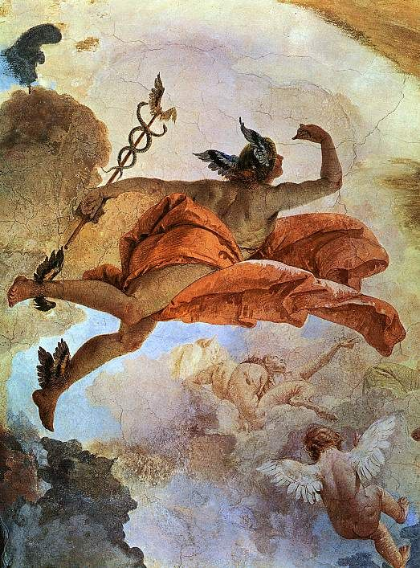

Jeremy Vuong

HRS 119 - Classical Mythology

Fall 2022

Prof. Mathias Warnes

In Greek mythology, Hermes was one of the twelve Olympian gods. He was the son of Zeus, the king of gods, and Maia, a nymph. Hermes was known to have many skills and talents. Some of his most notable skills and talents were his sense of direction and proficiency in spoken word. Another noteworthy feature of Hermes is that he was the only god permitted to freely traverse all the realms of the Greek cosmos. Thus, Hermes functioned as a messenger and guide in Greek mythology and earned epithets like “messenger of the gods” and “guide of souls”. However, restricting Hermes to these roles would be unjust as he is a much more sophisticated and prominent god in Greek myth. Arlene Allan reflects this sophisticated view of Hermes in her book *Hermes*. In her book, Allan reveals many unspoken functions of this god in Greek mythology. She addresses many of Hermes’ epithets and gives discussion on how these epithets transcend their meaning. This essay will be focusing on chapters two and three of Allan’s book where many of Hermes’ functions in ancient Greek myth and society are discussed.

In chapters two and three of Allan’s book, Allan gives an in-depth discussion on Hermes’ roles as a messenger and as a guide. In chapter two, Allan proposes that Hermes was far more than just a messenger. The implication of this chapter is that Hermes was more of a transmitter than a messenger as he also functioned under the titles Herald, interpreter, and instructor. In chapter three, Allan writes about Hermes’ multiple functions related to his traveling prowess. She states that Hermes, as a consummate traveler, naturally functioned as a guide and gave him the responsibility to protect travelers. The idea of this chapter is that Hermes is the god associated with transitional activities in life; that Hermes offered guidance through transitional periods in life. But more specifically, Allan details how Hermes guided boys through the process of becoming men. In these chapters, Allan makes references to the Fourth *Homeric Hymn,* which is the *Homeric Hymn to Hermes*, the *Homeric Hymn to Demeter* and the *Odyssey* to convey her ideas.

Hermes is well known in Greek mythology for his role in conveying messages between the gods. He has many poetic epithets that reflect this; namely *Angelos Athanat*ô*n*, which means “messenger of the deathless”, and *Angelos Makar*ô*n*, which translates to “messenger of the blessed ones” (Allan 39). Lesser known about Hermes is his role as Zeus’ Herald. Being the Herald of Zeus also meant that Hermes was the Herald of all gods as Zeus speaks for all gods (Allan 43). Allan begins chapter two of her book by discussing Hermes’ role as Zeus’ Herald. In Allan’s words, a Herald is “the title of a state official, one who has been granted the authority to speak in the name of the head of state and who is sent by that official to deliver, verbatim, that official’s words” (41). In the *Homeric Hymn to Demeter*, Hermes’ function as Herald of Zeus is displayed as he is sent by Zeus to the realm of Hades to solicit the release of Persephone. It would be a mistake to label Hermes as a messenger in this event as Hermes is speaking as Zeus rather than speaking for Zeus. Hades recognizes this and complies as Hades has great respect for Zeus. If Hades did not recognize the role of Hermes as Herald here, he would not have fulfilled the requests. Allan further emphasizes the importance of a Hermes’ role as Herald by writing, “so sacred were the men serving as official Heralds that to kill one knowingly was punishable by death” (42). Allan makes it clear that Hermes was a well-respected and prestigious god as he served as official Herald of the Olympian pantheon.

Allan continues chapter two of her book by addressing Hermes’ roles as an interpreter and as an instructor. Allan suggests that Hermes delivered messages in dreams. In the section of this chapter labeled “Leader of Dreams”, Allan writes, “The *Homeric Hymn to Hermes* (4.13-15) explicitly tells us that Hermes is ‘the leader of dreams’ as well as ‘the watcher by night’”. She also brings to attention that in the *Odyssey*, Homer reveals that there are two gates in the underworld for dreams to pass through. Dreams that exited the gate made of hewn ivory had no meaning but dreams that exited the other, the one made of polished horn, come to fruition (Allan 45). This detail revealed by Allan about the *Odyssey* does not explicitly involve Hermes but given that Hermes had the role as guide and was the only god that was able to freely access all realms of the Greek cosmos, inferences of Hermes involvement in are made. It is implied here that Hermes had a prophetic function. Specifically, it is implied that he led dreams through the polished horn gate to give them meaning. It is well known that subliminal messages are contained within dreams and these subliminal messages, when realized, provide interpretations for dreams. Allan is inferring that Hermes helped deliver these messages and in doing so, he also interpreted dreams. Allan continues chapter three with a discussion on Hermes’ function as an instructor. In this discussion she provides a great deal of evidence that suggests Hermes functioned as an educator. She first accentuates Hermes’ ability to remember things by referring to Hermes’ mnemonic recital of “the story of the deathless gods and of the dark earth” (Evelyn-White 414) in the Fourth *Homeric* Hymn. She says that this “makes him a ‘natural’ instructor and thus one who has oversight of persons and places involved with learning” (47). She refers to the *Homeric Hymn to Hermes* again and states that Hermes “even displays this aptitude for teaching when he offers to instruct his brother how to play the lyre…” (48). Allan also informs that “Hermes was made one of the three gods who oversaw the education and training of young boys and adolescents in the formal settings of the gymnasium and *palaistra* (wrestling ground)” (48). Undoubted then is Hermes’ qualifications and recognition as an instructor.

Hermes is highly touted in Greek mythology for his ability to get around. This is made evident in the Fourth *Homeric Hymn.* In the hymn, Hermes, at only a few hours of age, leaves his birth cave to venture around, making his way to distant locations and eventually returning in the night. He does this with no help whatsoever. Thus, it is clear why Hermes functioned as a guide in the Olympian pantheon. In chapter three, Allan provides discourse on Hermes’ other functions related to his role as guide. As a guide, Hermes also functioned as a protector of travelers. She states that his role as protector of travelers is revealed from Herms, which were rectangular statues with a sculpture of Hermes’ head on top, and from a collection of epigrams that portray Hermes as a talking Herm. Herms were typically found on travel routes in ancient Greece where they directed travelers where to go as the head of Hermes on the statue faced the direction of the next town. Allan states that in the epigrams, Hermes “is represented as a speaking Herm, inviting the weary traveller to pause and take a rest in the shade of the tree under which he has been set up and to refresh himself with water from the nearby fountain” (Allan 56). Hermes’ function as a protector of travelers is also displayed in Greek myths. In the *Odyssey*, Hermes protects Odysseus before he confronts the witch named Circe by giving him the plant ‘moly’ which was an antidote to Circe’s witchcraft. Later in this chapter, Allan brings attention to the frequent depiction of Hermes as a youthful adolescent. She states that this is an indication of his association with adolescent boys and proposes that Hermes guided adolescent boys in their transitions into men. Allan states that in ancient Greece, the “*gymnasion* and the *palaistra*” were directly involved with a boy’s maturation (64). As identified earlier, Hermes is a god who oversaw education in these settings. Allan suggests that as an instructor in these settings, Hermes was the “initiator of youths in their rites-of-passage trials” (65). Thus, Hermes was directly involved in the process of boys transitioning into men in ancient Greek society.

This essay has discussed chapters two and three from Arlene Allan’s book, *Hermes*. From these two chapters, it is clear that Hermes had many roles and functioned under many titles in ancient Greece. In these chapters, Allan accentuates the importance that Hermes had in Greek myth and society by providing an in-depth discourse on Hermes’ unspoken roles and functions. In chapter two, she proposes that Hermes’ role was beyond that of a divine messenger as she identifies and discusses Hermes’ roles as the Herald of Zeus, interpreter of dreams, and transmitter of knowledge and skill. In chapter three, Allan weighs in on Hermes’ role as a protector of travelers and his association with the transitional periods in a young man’s life. In these chapters of her book, Allan unmistakably rejects the notion that Hermes is a simple and insignificant god. Instead, she projects the idea that Hermes was a fascinating god who had many key roles in ancient Greek myth and society.

Works Cited

Allan, Arlene. “Transmissions.” *Hermes*, Routledge, London, 2018, pp. 39–52. Gods and Heroes of the Ancient World.

Allan, Arlene. “Transitions.” *Hermes*, Routledge, London, 2018, pp. 53–68. Gods and Heroes of the Ancient World.

Morford, Mark P. O., et al. “Hermes.” *Classical Mythology*, 10th ed., Oxford University Press, Oxford, 2014, pp. 285–303.

“Homeric Hymns 4.” Translated by Hugh G. Evelyn-White, *HOMERIC HYMNS 4 - Theoi Classical Texts Library*, <https://www.theoi.com/Text/HomericHymns2.html>.

Mellenthin, Jessica, and Susan O. Shapiro. “Hermes.” *Mythology Unbound: An Online Textbook for Classical Mythology*, Rebus Community, 2017, pp. 113–123.

“Herm (Sculpture).” *Wikipedia*, Wikimedia Foundation, 12 Oct. 2022, https://en.wikipedia.org/wiki/Herm_(sculpture).